COVID 19 SCENARIO PLANNING FOR THE THIRD SECTOR

Understanding Crisis Response Measures
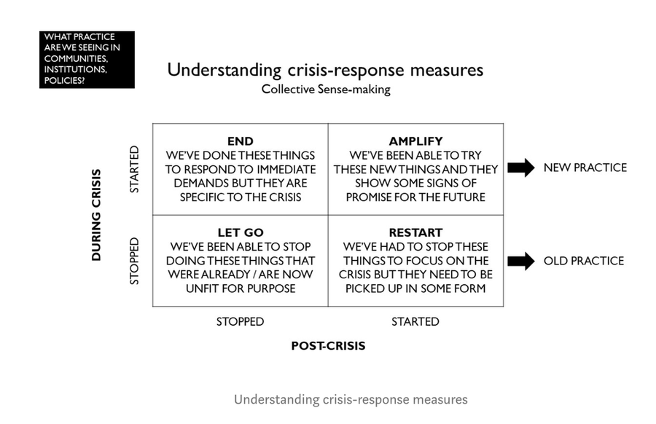
Diagram from RSA
https://www.thersa.org

Scenario planning framework

Scenario | Timescale | Staffing implications | Technology & premises implications | Volunteer implications | Trading implications | Grant implications | Other
1.  Current lockdown restrictions continue for another three months | Until end of July 2020
2.  Lockdown restrictions lifted temporarily | From 7th May
3.  Lockdown restrictions lifted but only some schools/workplaces open | From August 2020
4. Lockdown restrictions lifted but social distancing continues  As head into winter be aware that a second wave may hit and we return to full lockdown and scenario 1 | From October 2020
4. Lockdown restrictions lifted but social distancing continues

5. Long term continued social distancing | Summer 2021
6.  Lockdown ends and everyone returns to work, social distancing ends | October 2021

This document was drafted by Midlothian Third Sector Interface, Midlothian Council and Midlothian Health and Social Care Partnership.

