

Community Climate Action Plan

Camelon and Tamfourhill


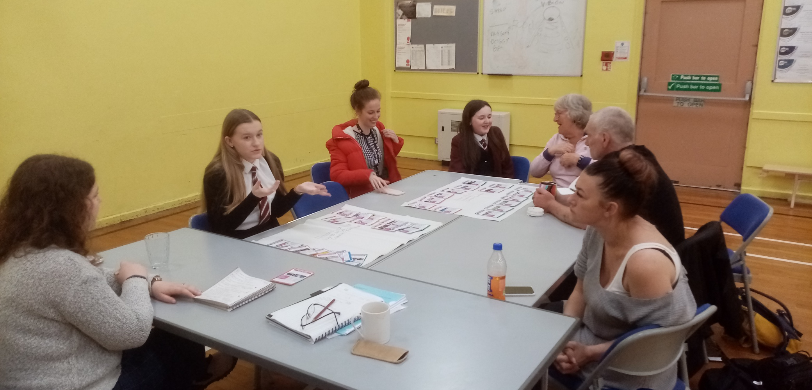

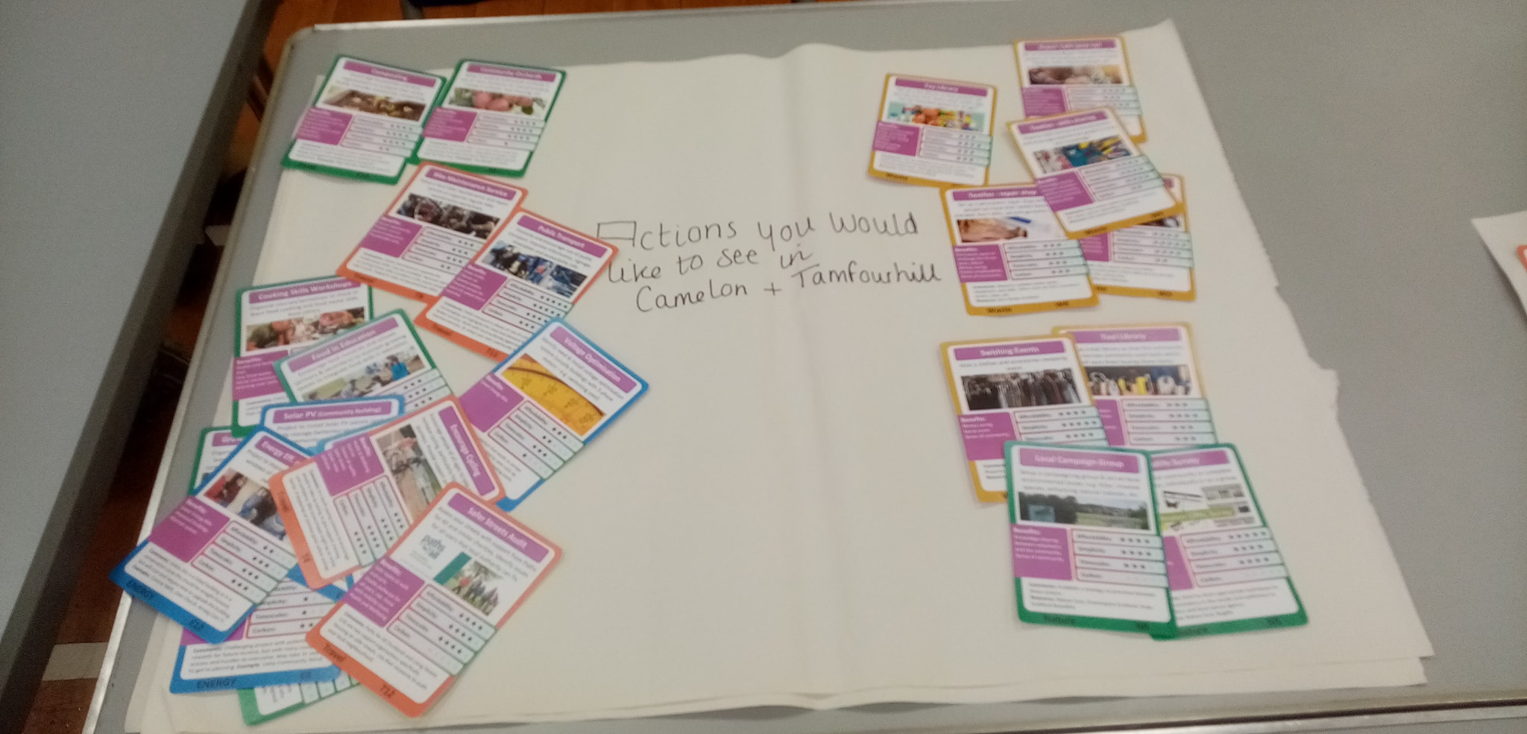

Foreword

The Climate Emergency is a community safety priority and now more than ever we need to think global and act local. Climate change is having a significant impact upon our safety in both the outdoors and in our homes and a considerable negative impact upon our personal health and wellbeing. The current energy cost crisis is also part of the climate change phenomena and with the prospect of increased home insurance to cover extreme weather incidents it's now critically important that we take the necessary steps to address these social, economic, and environmental problems and the creation of the Community Climate Action Plan for Camelon and Tamfourhill is the start of that process. John R Hosie Community Safety Engager: Our Place Camelon & Tamfourhill
“’The time for action is now’, stated the most recent report from the Intergovernmental Panel on Climate Change which also highlighted the need for ‘rapid, deep and immediate’ cuts to carbon emissions. Keep Scotland Beautiful fully supports this message and has been delighted to support Camelon and Tamfourhill to recognise the climate action they already take, and to work together to create a plan to reduce carbon emissions and create a cleaner, greener, more financially secure community”. Catherine Gee – Deputy CEO of Keep Scotland Beautiful

Camelon and Tamfourhill
Historic villages in the Forth Valley.

Camelon and Tamfourhill Community Climate Action Plan programme was part of a project with Falkirk Council and Green Action Trust called Falkirk Canal Connections. The project has received £720,120 from the UK Government through the UK Community Renewal Fund as announced on 3 November 2021.
The Community Climate Action Plan programme, which was facilitated by Keep Scotland Beautiful, supported Camelon and Tamfourhill through a series of workshops, activities and events in spring/summer 2022 to create their own community climate action plan. This document is the result of this programme.
“Community [climate] action can deliver real impact in terms of [reducing] CO₂, waste reduction, and reuse and redistribution of food, furniture, clothing, toys and material. And, in doing so, it generates important wider benefits: improving health and wellbeing, increasing community pride, and supporting skills, training and jobs”.
Residents of the communities of Camelon and Tamfourhill looked at the environmental and local challenges, and opportunities, and worked together to form a draft plan.
Those directly involved in the sessions have been collecting, discussing and sharing ideas, but they also recognise that this is a collaborative journey and are actively looking for comments and contributions from the wider community too. This will always be a ‘work-in-progress’.
Camelon and Tamfourhill Community Climate Action Plan itself is not a fixed document. It is a live, moving, flexible document in need of regular review. Climate actions laid out in the document can be changed, they can be actioned sooner, later or removed. New actions can be added at any time. This is a community document, therefore anyone in Camelon and Tamfourhill can contribute, and anyone can play a part in delivering on the climate actions identified in the plan.
Comments and support for this plan (or a variation of it) will be warmly welcomed.
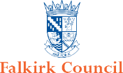
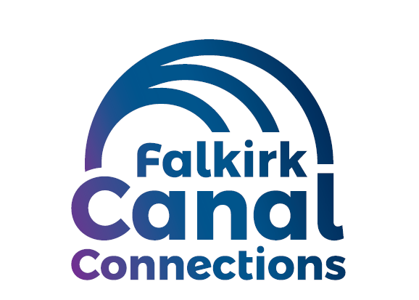


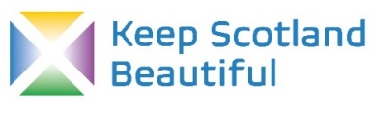
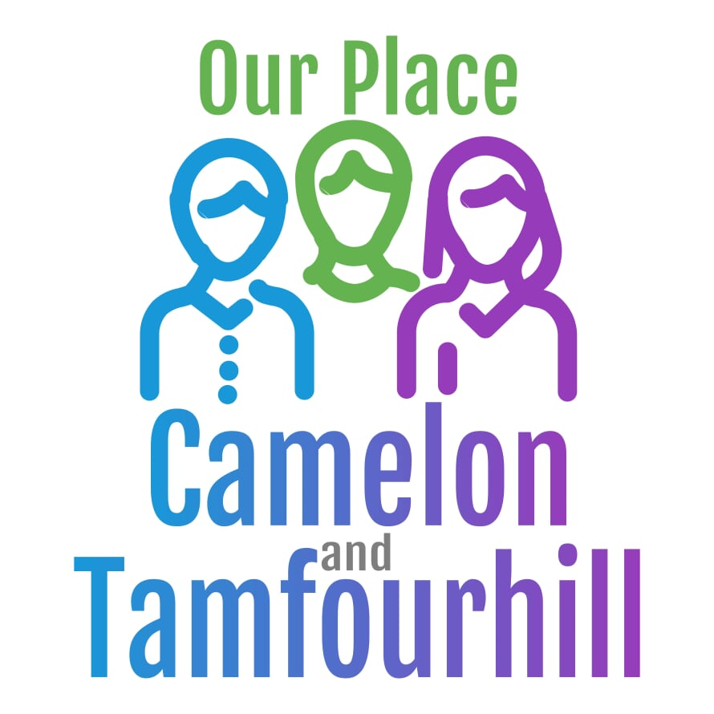

A Snapshot of Camelon and Tamfourhill in 2022

Population: Approximately 5,808
Camelon is a village located in the Forth Valley within the Falkirk local authority. Camelon has a lot of history, with links to the bronze age and is the site of a series of roman fortifications including the Antonine Wall. Camelon developed when the canals were built in the 18th and 19th centuries.
Tamfourhill consists of the residential area between the south side of the Forth & Clyde Canal and the north side of the Union Canal. The Falkirk Wheel is located just to the northwest of the village.

Community energy consumption

Electricity
(please consider adding your community’s electricity consumption here)

Heat
(please consider adding your community’s electricity consumption here)

Weather and climate change related disruption
(please consider adding any additional weather and/or climate disruption that your community has faced here).
- The River Carron burst its banks and flooded Stirling Road after intense rainfall in February 2020.

- A883: Road at Camelon re-opens after weekend flood closure in February 2022.

- Storm Dudley clean-up operation continues as gales uproot trees across Falkirk in February 2022.

Community Climate Action Plan Programme – climate change survey for Camelon and Tamfourhill community

A short survey, prepared by Keep Scotland Beautiful, asked participants about their knowledge of climate change, how they would prioritise climate change, whether they think it affects or will affect Camelon and Tamfourhill, and the type of climate action they would like to see in Camelon and Tamfourhill.
The graphs and word clouds below show the results of the survey. It is worth noting that this is a snapshot at this point in time from those who responded to the survey and is therefore not necessarily the overarching view of the whole community.
The survey data is split in two, the first graphs and word clouds are from a mix of participants across the community - adults, young people and children. The word clouds are created from the written answers of those surveyed. Words that appeared regularly in respondents’ answers are bigger in the word cloud. The second lot of graphs and word clouds are survey data from young people at Falkirk High School.

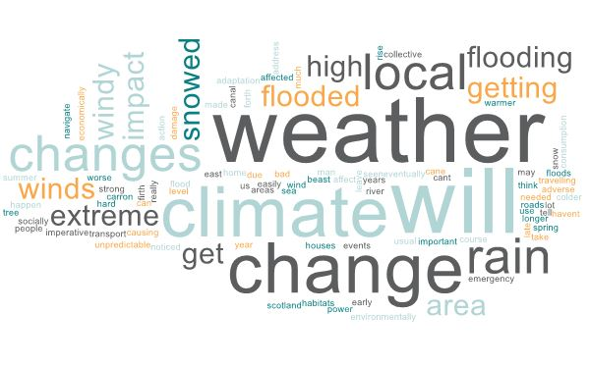
Do you think climate change affects/will affect Camelon and Tamfourhill? For example, have you been affected by extreme weather? (Such as flooding, heatwaves, strong winds or heavy snowfall etc.) Please comment on your answer (25 responses)

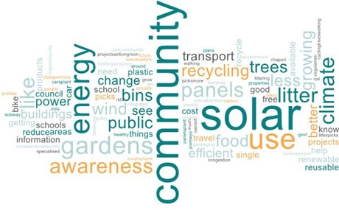
What kind of climate action would you like to see in Camelon and Tamfourhill and wider Falkirk? (66 responses).

Falkirk High School pupils’ climate change survey responses.

Do you think climate change affects/will affect Camelon and Tamfourhill? For example, have you been affected by extreme weather? (Such as flooding, heatwaves, strong winds or heavy snowfall etc.) Please comment on your answer (139 responses).
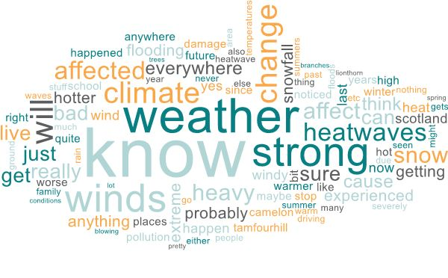
What kind of climate action would you like to see in Camelon and Tamfourhill and wider Falkirk? (139 responses)
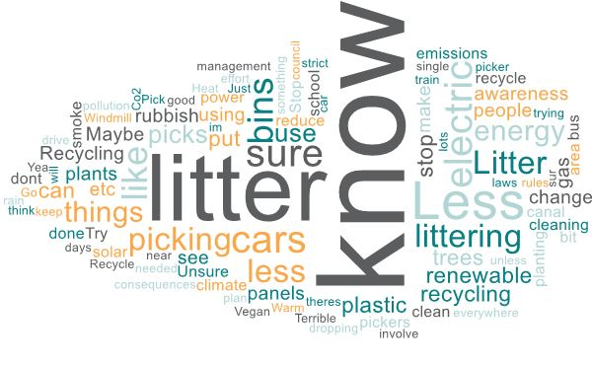
Reflection (feel free to add a reflection from the community on the issues the graphs have raised, for example, are these results expected / unexpected? Are there differences between the school pupils and the general public responses?).

The Climate Crisis in 2022
The Intergovernmental Panel on Climate Change released a report on 28th February 2022 that explained that the threat that climate change poses to human well-being and the health of the planet is “unequivocal”. The fossil fuels that we regularly emit into the atmosphere are causing the global average temperature to increase and this is having significant effect on our communities and our planet.
Globally, we are seeing increased wildfires in California and Australia, rising sea levels claiming land from Fiji, Kiribati, Tuvalu and the Maldives and extreme weather events causing catastrophic flooding in Bangladesh.
Closer to home in Scotland, we can expect and are experiencing hotter, dryer, summers, warmer, wetter, winters with less snow and more extreme weather events such as storms and wildfires.
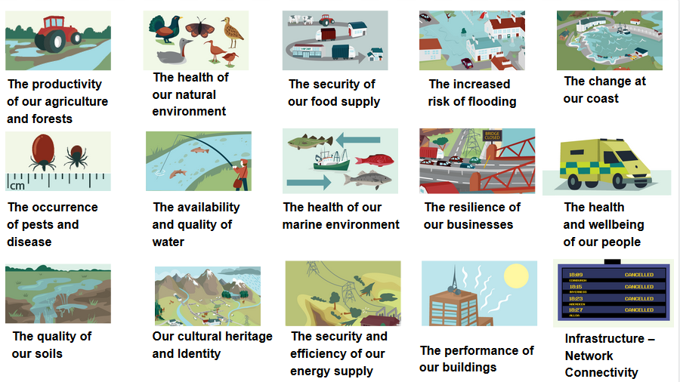
There will also be other impacts that are not always considered. The graphic below created by Adaptation Scotland shows some of the impacts that climate change may have. These include an increase in pests and disease, more pressure on network infrastructure like rail and the security of our food supply.

Adaptation Scotland

However, whilst some impacts are locked in, many are not and if we make changes, we can prevent some of the more significant impacts. The Scottish Government have set a target of Net Zero by 2045 (producing the same amount of greenhouse gas as the amount removed from the atmosphere). However, if we want to see significant changes to our emissions then we also have to work together as individuals to reduce our emissions in Scotland. This means making changes at local, community level. This Community Climate Action Plan aims to do just that.

The Process
This document is the record of a series of conversations that took place in late 2021/early 2022 to explore challenges and opportunities in Camelon and Tamfourhill and to map out some possible routes forward to work on. The conversations were supported by Scottish charity Keep Scotland Beautiful who facilitated sessions, took notes and guided everyone through the process. This work was funded by the UK Government through the UK Community Renewal Fund as part of an initiative with Falkirk Council and Green Action Trust called the Falkirk Canal Connections Project.
This series of conversations culminated in the creation of the Camelon and Tamfourhill Community Climate Action Plan grid which is located below on page 16. A toolkit provided by Keep Scotland Beautiful helped to create conversations around 6 different topics: Food, Energy, Waste, Travel, Adaptation and Nature.
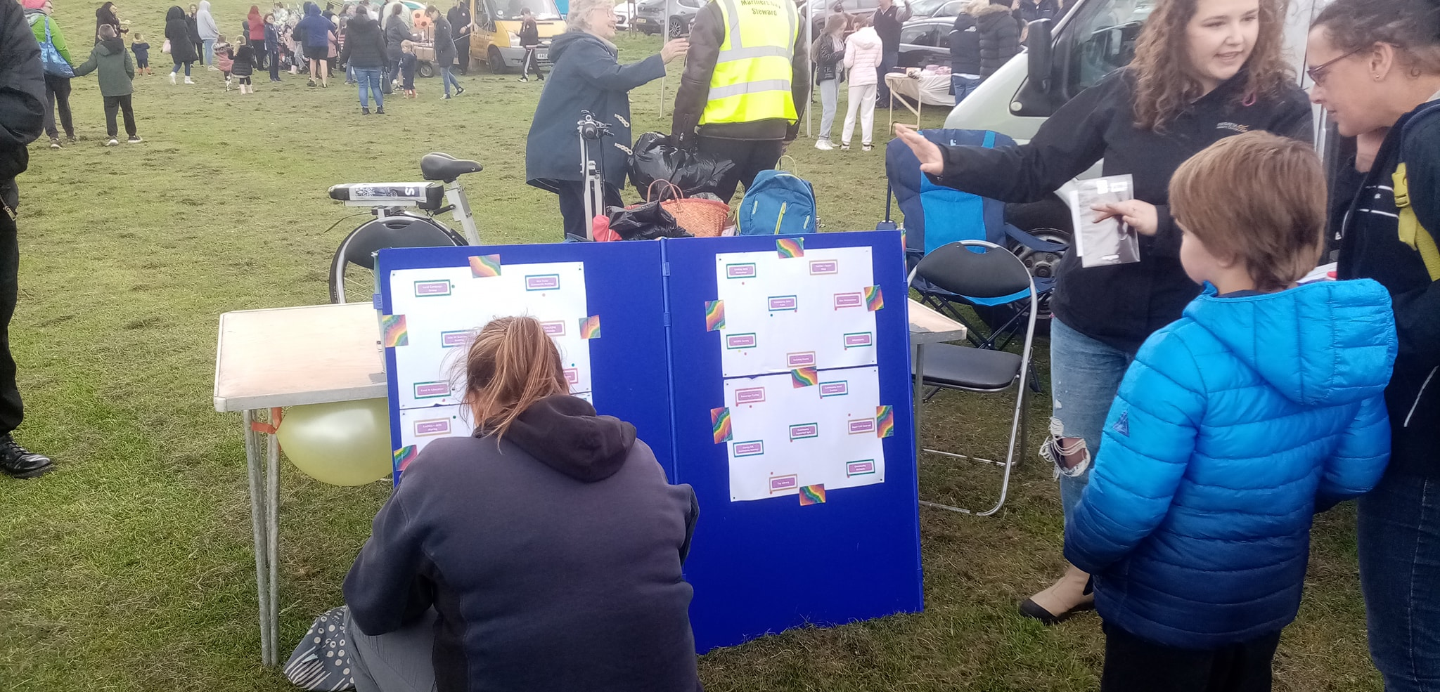

Current Achievements and Activities
In session conversations there were many comments about all the great work that was going on right now in Camelon and Tamfourhill but which not everyone knew about. To illustrate some of what’s going on right now, the table below gives some examples. There are likely to be many more. This also shows all the great actions happening in Camelon and Tamfourhill all in one place.

Current Activity | Led by | Status
Allotments | Falkirk Council | Already set up in 2 areas, would like to expand.
Cooking Skills Workshops | Tamfourhill Community Hub | Louise at Tamfourhill Community Hub runs parents and kids cooking workshops and does some with kids during the holidays.
Growing Skills Workshops | Bantaskin Primary School | Bantaskin Primary School have a big growing area.
Food Redistribution | Tamfourhill Community Hub | Partnered with Tesco and Greggs for the food pantry.
Community Food Shop | Tamfourhill Community Hub | Two food pantries in the local area.
Buy Direct | Cyrenians Farm | Make veg boxes that they have grown on their farm.
Composting | Forth Valley Sensory Centre  Barnardos | Composting happens at the Sensory Centre as well as at Barnardos which they allow people to use. Not sure if Bantaskin primary school still do this.
Insulation for Homes | Falkirk Council | The council is doing this for houses in the local area.
Solar PV for Homes | Falkirk Council | The council is doing this for houses in the local area.
Heat Pumps for Homes | Falkirk Council | The council is doing this for houses in the local area.
Litter Picks
Textiles – recycling facilities | Charity shops
Zero Waste Shop
Tool Library | Tamfourhill Community Hub | Tamfourhill Community Hub have one at the hub and there is also a cleanup tool library in the community.
Promote Outdoor Learning | Schools
Outdoor Classes | Schools
Walking in Nature
Tree Planting Days
Community Woodland
Wildflower Meadows
Park Cleans
Local Campaign Group | Tidy, Clean and Green Working Group | Local group already set up and working hard in the community.
Car Club | Bantaskin Primary School | The car park at Bantaskin Primary School has a car club – could do with some awareness raising.
Encourage Cycling | Primary schools | Easter Carmuirs do Bikeability and Dr Bike.
Cycling Infrastructure | Falkirk Council | Bike racks at the hospital, Tesco, Asda and the train station.
Bike Hire | Forth Environment Link  Scottish Canals | Bikes can be hired at the hospital. Scottish Canals also do bike hire and general hire around the community. Active Travel Hub in Falkirk.
Promote E-Bike Benefits | Scottish Canals  Forth Environment Link | Scottish Canals and Forth Environment Link are doing this in the local area.
Bike Maintenance Service | Schools | Happens in schools already and in Camelon.
Public Transport | Falkirk High School | Falkirk High School working on helping under 22s get their free travel.
Safer Streets Audit | Community Safety Engager | John is working on this already, doing some walking audits. Received funding to change layout around the schools.
Active Travel Maps
Walk Don’t Drive
Green Tourism | Falkirk Wheel | Green Key Accreditation currently being undertaken at the Falkirk Wheel – would like to see the community benefit from this tourism.
Core paths | Sustrans  Green Action Trust  Forth Env Link | A core path network already in place.

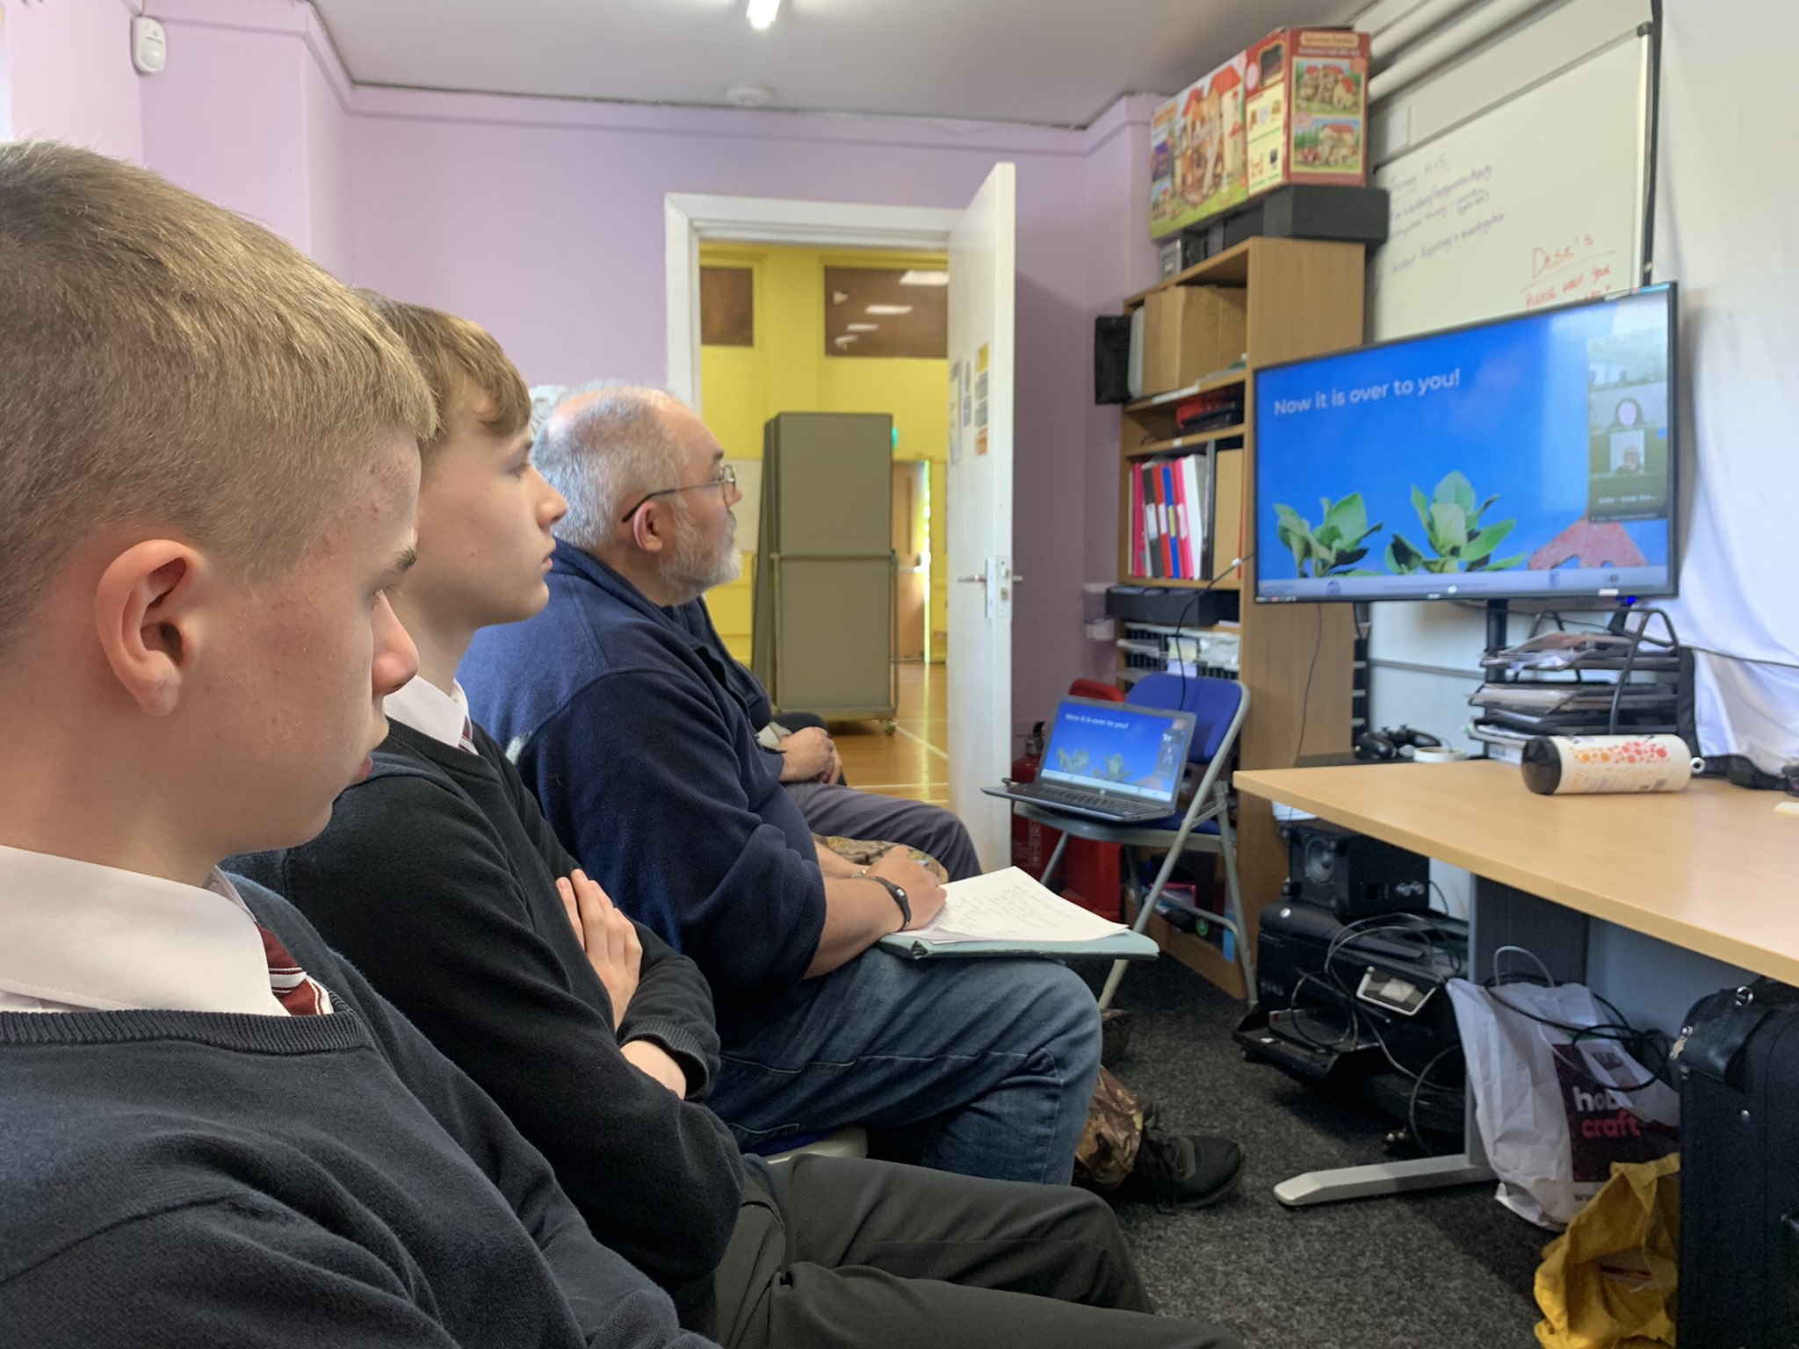mages

Camelon and Tamfourhill’s Community Climate Action Plan Grid
1/ Start this ourselves in 1 year

Allotments
Tool Library
Toy Library
LED Lights for Homes

3/ Start to support in 1 year but belongs to others

2/ Start this with partnerships in 1 year

Growing Skills Workshop
Food in Education
Community Orchards
Cooking Skills Workshop
Promote Bike Maintenance Service
Solar PV (Community Building)
Energy Efficiency (Community Building)
Wildlife Survey

6/ Start to support in 1-2 years but belongs to others

4/ Start this ourselves in 1-2 years

Encourage Cycling

9/ Start to support in 2+ year but belongs to others

5/ Start this with partnerships in 1-2 years

Swishing Events
Community Supported Agri.
Composting
Heat Pump (Community Building)
Community Solar Farm

7/ Start this ourselves in 2+ years

8/ Start this with partnerships in 2+ years

Bike Hire
Community Wind Turbine
Textiles – repair shops
Textiles – skills sharing
Repair Café (pop-up)
Re-/Up-cycling Workshops

Future Short-Term Actions
Below is a table of actions proposed for the next 12 months (Boxes 1, 2 and 3 in the grid above). They are not listed in any particular order, and some can be done in parallel with others. This is a long list and may seem daunting, but this is a list of opportunities, and every small step is valuable. Some might have immediate capacity or potential for funding that could enable them to happen straight away, whilst others may need more buy-in or development time.
Partner organisations should be involved as early as possible, and connections with the council and local elected members should be expanded, both to gain increased support for local issues but also to highlight the benefits of community-led climate action plans and their ability to identify and provide evidence of the priorities voiced by local residents.

Action | Led by/Partners | Status
Allotments | Tidy, Clean and Green Working Group  Camelon and Tamfourhill Community  Falkirk Council | Working on setting up allotments at Brown Street. Tamfourhill Centre also want to do some allotments, currently waiting to clear space. Also looking to do some food growing on some waste land, funding from the Dandelion Fund or the community growing officer at Falkirk Council. Food growing space at Falkirk High but a bit neglected – Gardening club looking to do something about it.
Tool Library | Tamfourhill Community Hub  Camelon and Tamfourhill Community | Already have the tools, just looking for a place to store and someone to be administrator. Talk to the Sensory Centre.
Toy Library | Forth Valley Sensory Centre  Tidy, Clean and Green Working Group  Camelon and Tamfourhill Community | Looking to set this up at the Sensory Centre.
LED Lights for Homes | Tamfourhill Community Hub  Camelon and Tamfourhill Community | Simple project that could support members of the local community.
Growing Skills Workshop | Falkirk High, Tamfourhill Community Hub, Tidy, Clean and Green and the Sensory Centre.  Camelon and Tamfourhill Community | Growing Skills Partnership. A teacher at the school is up for supporting growing and cooking. Community and school both keen to work together on this. Falkirk High would like to improve what they have currently.
Food in Education | Falkirk High School  Tamfourhill Community Hub  Camelon and Tamfourhill Community | Community and Falkirk High partnership on this. Maybe with local primary schools as well.
Community Orchards | Forth Valley Sensory Centre  Tamfourhill Community Hub  Camelon and Tamfourhill Community  Falkirk Council | Looking to do this at the Sensory Centre. Could be done around the hub. School could do this as well. Biodiversity Officer at the council willing to supply the trees. Could plant some at Brown Street or Camelon Juniors Car Park.
Cooking Skills Workshop | Falkirk High  Tamfourhill Community Hub  Forth Environment Link  Forth Valley Sensory Centre  Camelon and Tamfourhill Community | Big priority for the school. Tamfourhill Community Hub looking to expand current workshops. Looking to get certified so they can train others and give out certificates. Falkirk High – pupils would like these workshops at school / after school. Create a partnership between community and school to work on this.
Promote Bike Maintenance Service | Falkirk High School  Tamfourhill Community Hub  Forth Environment Link  Camelon and Tamfourhill Community  Sustrans | Encourage parents and teens to go on servicing courses. Scott Walker does bike maintenance in the local area. Forth Environment Link also do work around this.  Possibility to support children from the High School to attend bike maintenance courses and then support this service.
Solar PV (Community Building) | Tamfourhill Community Hub  Local Energy Scotland  Community Energy Scotland | Tamfourhill Community Hub really keen to retrofit their community building with support from partners.
Energy Eff. (Community Building) | Tamfourhill Community Hub  Local Energy Scotland  Community Energy Scotland  Forth Valley Sensory Centre  Falkirk Climate Change Team | Tamfourhill Community Hub really keen to retrofit their community building with support from partners.  Will be challenges, such as getting the committee on board.
Wildlife Survey | Falkirk High School  Camelon and Tamfourhill Community  Tamfourhill Community Hub  Scottish Wildlife Trust  RSPB | Definitely an action that Falkirk High could get involved in. Could partner with regional partners such as Scottish Wildlife Trust and RSPB.

Below is a table that lists other actions that were also considered, but they would be started within the next one to two years (Boxes 4, 5 and 6 in the grid). They are equally relevant and could be brought forward if time and capacity allowed.

Action | Led by/Partners | Status
Encourage Cycling | Camelon and Tamfourhill Community  Primary Schools  Sustrans | Easter Carmuirs do Bikeability and Dr Bike. Promote this and the work that others are already doing on it through posters etc.
Swishing Events | Camelon and Tamfourhill Community
Community Supported Agri. | Camelon and Tamfourhill Community  Falkirk Council | Would need about half an acre – expertise in the community already there but an aspirational goal.
Composting | Falkirk High  Camelon and Tamfourhill Community | Something that Falkirk High could do with the Gardening Club, with support from the eco-club.  Barnardo’s could help.
Heat Pump (Community Building) | Tamfourhill Community Hub  Local Energy Scotland  Community Energy Scotland  Camelon and Tamfourhill Community | Tamfourhill Community Hub really keen to retrofit their community building with support from partners.
Community Solar Farm | Local Energy Scotland  Community Energy Scotland  Camelon and Tamfourhill Community  Falkirk Council | An aspirational project to have local community, affordable clean energy in Camelon and Tamfourhill. Need to speak about partners, leasing land from the council, funding and experience. Easier than turbines.

I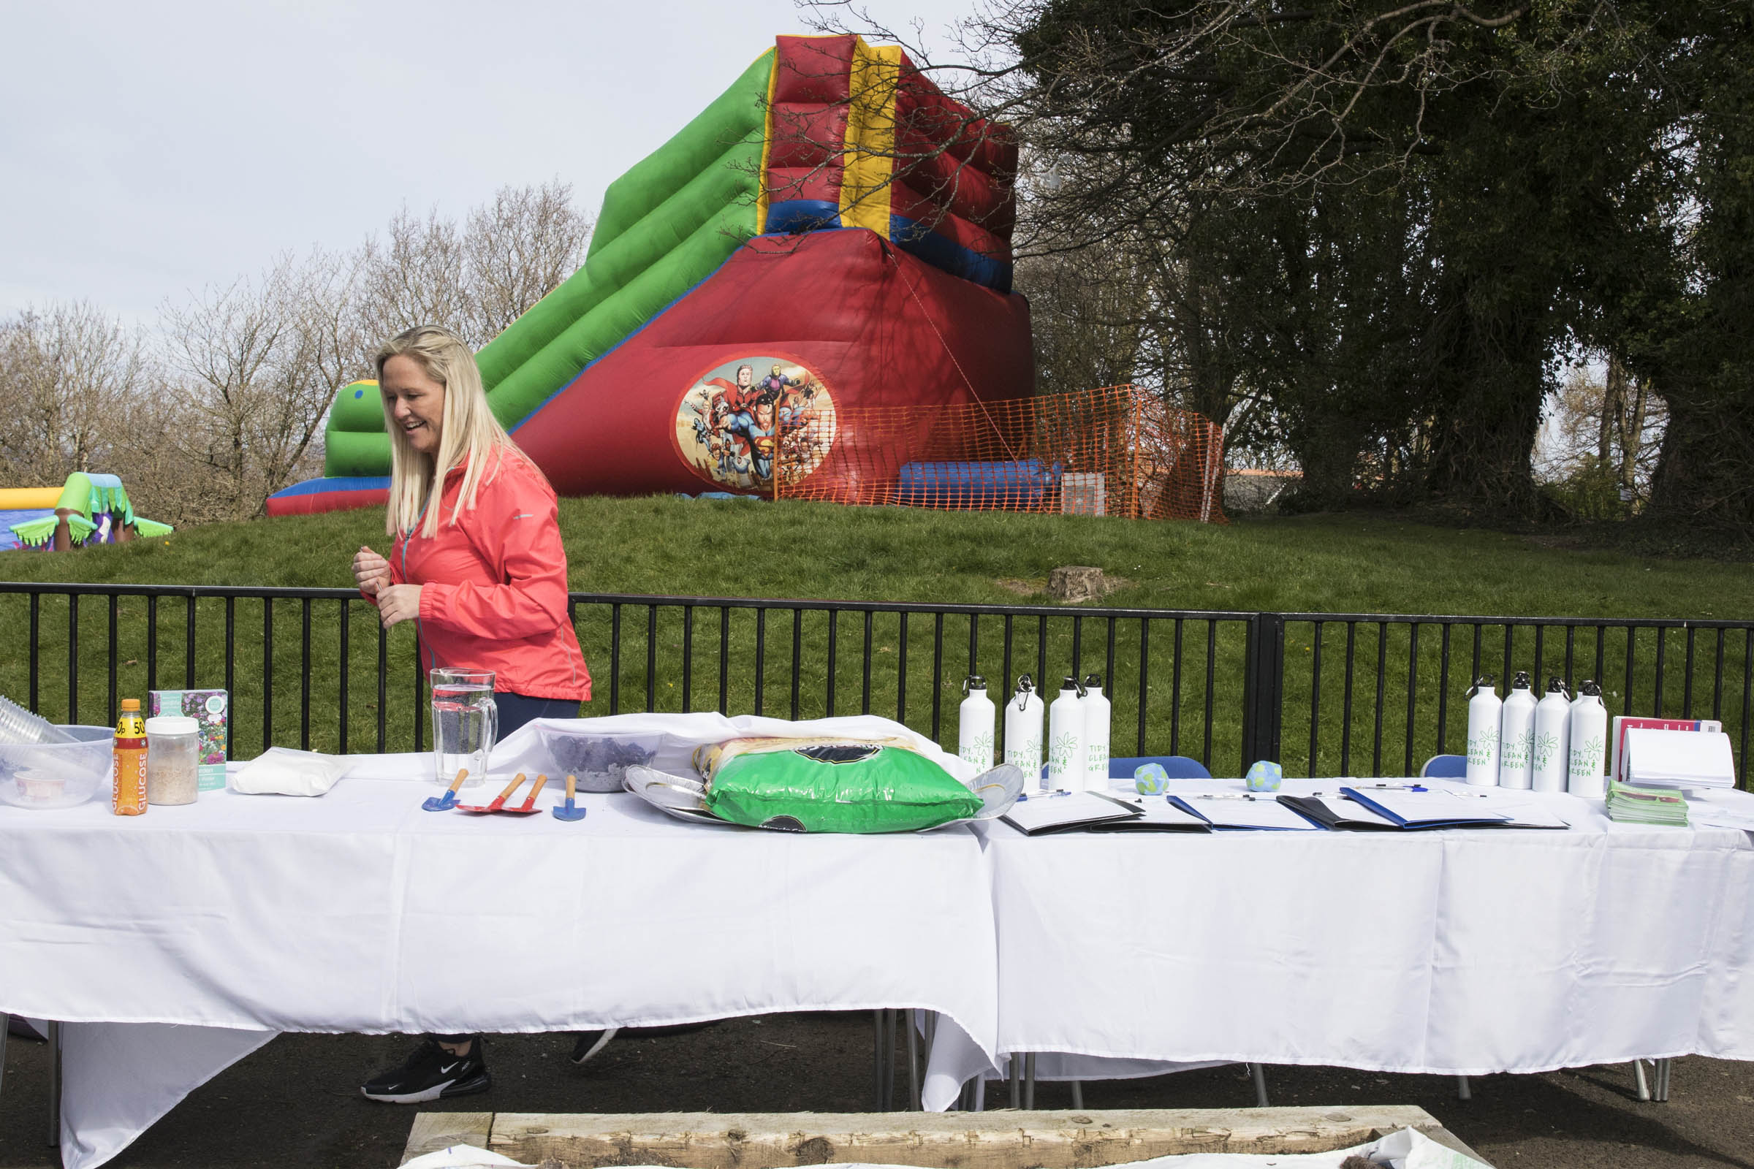mage/images

Longer Term Actions
A range of actions were identified as worthy for consideration in the second or subsequent years (Boxes 7, 8 and 9 in the grid), and some of these may require more research to determine if they are realistic or needed. Community engagement would need to be expanded for some of them to determine the level of interest and support for each.

Action | Led by/ Partner | Status
Bike Hire | Tamfourhill Community Hub  Camelon and Tamfourhill Community  Sustans  Forth Environment Link | Tamfourhill Community Hub are keen to have a bike hire station set up at the Hub.
Community Wind Turbine | Local Energy Scotland  Community Energy Scotland  Camelon and Tamfourhill Community  Falkirk Council | An aspirational project to have local community, affordable clean energy in Camelon and Tamfourhill. Need to speak about partners, leasing land from the council, funding and experience.
Textiles – repair shops

Textiles – skills sharing
Repair Café (pop-up)

Re-/Up-cycling Workshops

Governance
(Please add to this section as ideas on governance solidify).
A steering group – a group of partners, support each other with funding applications and projects.
Partners include:
- Our Place Camelon and Tamfourhill
- Tamfourhill Community Hub
- Tidy Clean and Green Group
- Forth Valley Sensory Centre
- Go Forth and Clyde
- Falkirk High School
Meet every three months.

Next Steps
Now that Camelon and Tamfourhill have completed the Community Climate Action Plan programme, they are welcome to join the Community Climate Action Plan network, where communities can support each other on their journeys.
Other programmes available from Keep Scotland Beautiful that could bolster climate action, include Eco-Schools, Climate Emergency Training, Beautiful Scotland and It’s Your Neighbourhood, Clean Up Scotland and Green Flag Award for Parks.
This programme was funded as part of the Falkirk Canal Connections Project. Another element of this work is a Net Zero Masterplan for The Falkirk Wheel, a sustainability plan put into place by Scottish Canals. Going forward there is scope to identify common ground where climate action could be taken together in partnership.

As part of the initial Community Climate Action Plan process, the community has already decided on a number of achievable next steps as noted here:
(Please add targets with dates to this section. A target could simply be to meet up again to consider what the next steps are)
- A plan launch at the end of August/early September. Venue to be confirmed - somewhere outside.

- Set up a Facebook group about the Community Climate Action Plan to update the community and let them know what’s happening and how they can get involved. Partner groups will share this information on their social media platforms.

- Consider getting Scottish Canals and Falkirk Council on board.

- Involve the children who attend Tamfourhill Community Hub and draw in the parents this way. Maybe ask teenagers from Falkirk High and other schools or the Hub to support projects. Connect up with events and fun days to reach people.

Plan Next Steps
- The tool library is now set up at Forth Valley Sensory Centre; needs building up with more tools. A shed is going to be built to store the tools.

- A cabin has been set up for the Toy Library, it just needs a door. Been asking the charity shops for toys and books, potential to ask on Facebook as well.

- Wanting to get the Brown Street Allotments up and running. Need to consult the community.

- Sarah from Forth Valley Sensory Centre is reaching out to Home Energy Scotland to find out how to source LED bulbs that can be offered to the community.

- Working on a partnership between Falkirk High and Tamfourhill Community Hub about cooking skills workshops. Approached senior management at the school. Cooking workshops would need to be after school. Conversations will continue once the schools are back. Also a possibility to partner with the NHS - a new person in post who could help with cooking skills training.

- Falkirk High School are considering restarting their growing spaces at the school. Tamfourhill Community Hub are in the process of expanding their growing space. Taken down some dangerous trees which has cleared some space. Would like to have a polytunnel installed at some point in the future. Sustainable Thinking Scotland could be a potential partner for this.

- The Forth Valley Sensory Centre, with support from Falkirk Council, are planting a community orchard on their land. Also considering a project to grow native fruit trees and bushes on green spaces around the community. Potential to do a green space audit, speak to Falkirk Council and possibly Scottish Canals about the tow paths.

- John, the Community Safety Engager is having a meeting with Forth Environment Link in August regarding bike maintenance services. Go Forth and Clyde do bike maintenance sessions on Fridays, 11-3pm – this is a trial. Tamfourhill Community Hub will share on social media as well as other bike repair services in the area.

- Tamfourhill Community Hub is looking at making the Hub more energy efficient and run it on renewable energy. First steps are to get in touch with Home Energy Scotland, speak to the board, discuss funding and have an energy efficiency audit. Meetings and research needed.

- Plantlife International do surveys, RSPB, insect versions. Could partner with Falkirk High School. Could do John Muir Award for conservation. Community Safety Engager will support John Muir Conservation and citizen science.

Appendix
Local Links and Organisations – (please add useful community organisations and links here)
Local Assets – (please add useful local assets and/or buildings here)

Contacts
- Community Energy Scotland - info@communityenergyscotland.org.uk
- Local Energy Scotland - info@localenergy.scot
- Forth Environment Link - info@forthenvironmentlink.org
- Sustainable Thinking Scotland - sustainablethinkingscotland@gmail.com
- Social Farms and Gardens – karen@farmgarden.org.uk
- Get Growing Scotland - hello@getgrowingscotland.org
For more contacts, please get in touch with Keep Scotland Beautiful and we will try to link you up.

Funding
National Lottery Awards for All Scotland Fund https://www.tnlcommunityfund.org.uk/funding/programmes/national-lottery-awards-for-all-scotland

The National Lottery Community Led Fund https://www.tnlcommunityfund.org.uk/funding/programmes/grants-for-community-led-activity

Scottish Council for Voluntary Organisations - different funding opportunities - can filter by region - https://funding.scot/

Aviva Community Fund
https://www.aviva.co.uk/services/more-from-aviva/aviva-community-fund/

Scottish Community Alliance – Community Learning Exchange: https://scottishcommunityalliance.org.uk/community-learning-exchange-2021/

Tesco Community Grants - https://www.greenspacescotland.org.uk/grant-funding

Place based resources

Place Standard Website - http://www.healthscotland.scot/health-inequalities/impact-of-social-and-physical-environments/place/the-place-standard-tool

Our Place – a site devoted to promoting the benefits of place and place-based working, developed by the partners behind the Place Standard tool - https://www.ourplace.scot/

“Community action for the environment” by The National Lottery Community Fund
Wikipedia
Wikipedia

