The proposal to pilot a twilight sports programme arose from a period of streetwork engagement, events in public parks and a youth survey which took place in the summer and autumn of 2021 and is highlighted in the report: Young People & Community Safety in Camelon and Tamfourhill.
The pilot project was also intended to be aligned to two key outcomes of the local community safety strategy: (1) The Community will have greater capacity to address the negative impacts of ASB, (2) There will be an increase in the number of Young people involved with projects and activities that address community safety and reduces their risk taking & (3) Young people will have increased opportunities to have their voices heard about the issues that affect their safety within the community.
The Twilight sessions were planned to operate from four locations throughout Camelon and Tamfourhill, each representing a distinct geographical neighbourhood and with the view to young people having easy access to the activity programmes on their own doorsteps. There was also an acknowledgment that young people already gathered in local public parks and that these locations could be problematic in terms of ASB and could involve young people with risk taking behaviour. The programme was to be targeted at 10–16-year-olds and the key facets of the programme were stated as:
•Providing positive healthy diversionary sporting activities at key times and locations where young people were at risk of drifting into problematic circumstances including ASB and causing an array of community safety concerns.
•Facilitating positive relationship building with local community organisations and providing an outreach connection point for community safety partners, in particular the Police and Fire and Rescue Service and potentially where other agencies could deliver an array of workshops and community safety inputs.
• The participating young people would be signposted and supported to access other sporting and recreational activities both locally and further afield.
• The Pilot would be delivered as a community development project encouraging the involvement of parents and other community members.
•The Pilot sessions are aligned to key outcomes of the local community safety strategy. (As detailed above)
The Pilot Project received funding through the Camelon Community Sports Hub Covid-19 restart fund and this was match funded by Police Scotland in Falkirk.
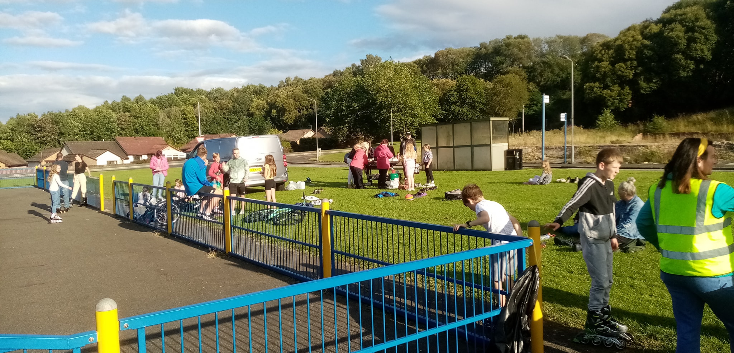

The Programme operated from April to August, and after two initial taster sessions held over the Easter School holidays the full programme began on Friday 22nd April and ran for 14 weeks. The four intended locations were: The MUGA on Carradale Ave in Tamfourhill, Easter Carmuirs Park, Nailer Road Park and CJFC Car park area. (Due to unforeseen circumstances this last location was not used, and the last four weeks of the programme were relocated back to the MUGA on Carradale Ave in Tamfourhill.) The Programmes sessions were to rotate around the different locations on a 4-week basis with each location having a lead sport with additional activities also available and with the community safety partners attending when available. In practice due to its substantial popularity the programme involved the Falkirk Wheelers delivering rollerblading at every session for 14 weeks, with football delivering 8 sessions, Rugby 2 sessions and The Conservation Volunteers delivered nature based and outdoor cooking activities at 4 of the sessions. The majority of the sessions had the Fire and Rescue Service in attendance for a part of the evening along with their fire engines and the Community Police officers were regular visitors to the programme. The involvement of these services was greatly appreciated by the wider community and was a weekly highlight for the participating young people. Forth Environment Link provided their Dr Bike Service at 4 sessions at 2 of the locations, this was incredibly popular and an important community safety aspect to the wider programme. Due to public and staff holidays 2 sessions were cancelled hence why only 14 of the planned 16 sessions took place. A detailed programme is appended to this report.
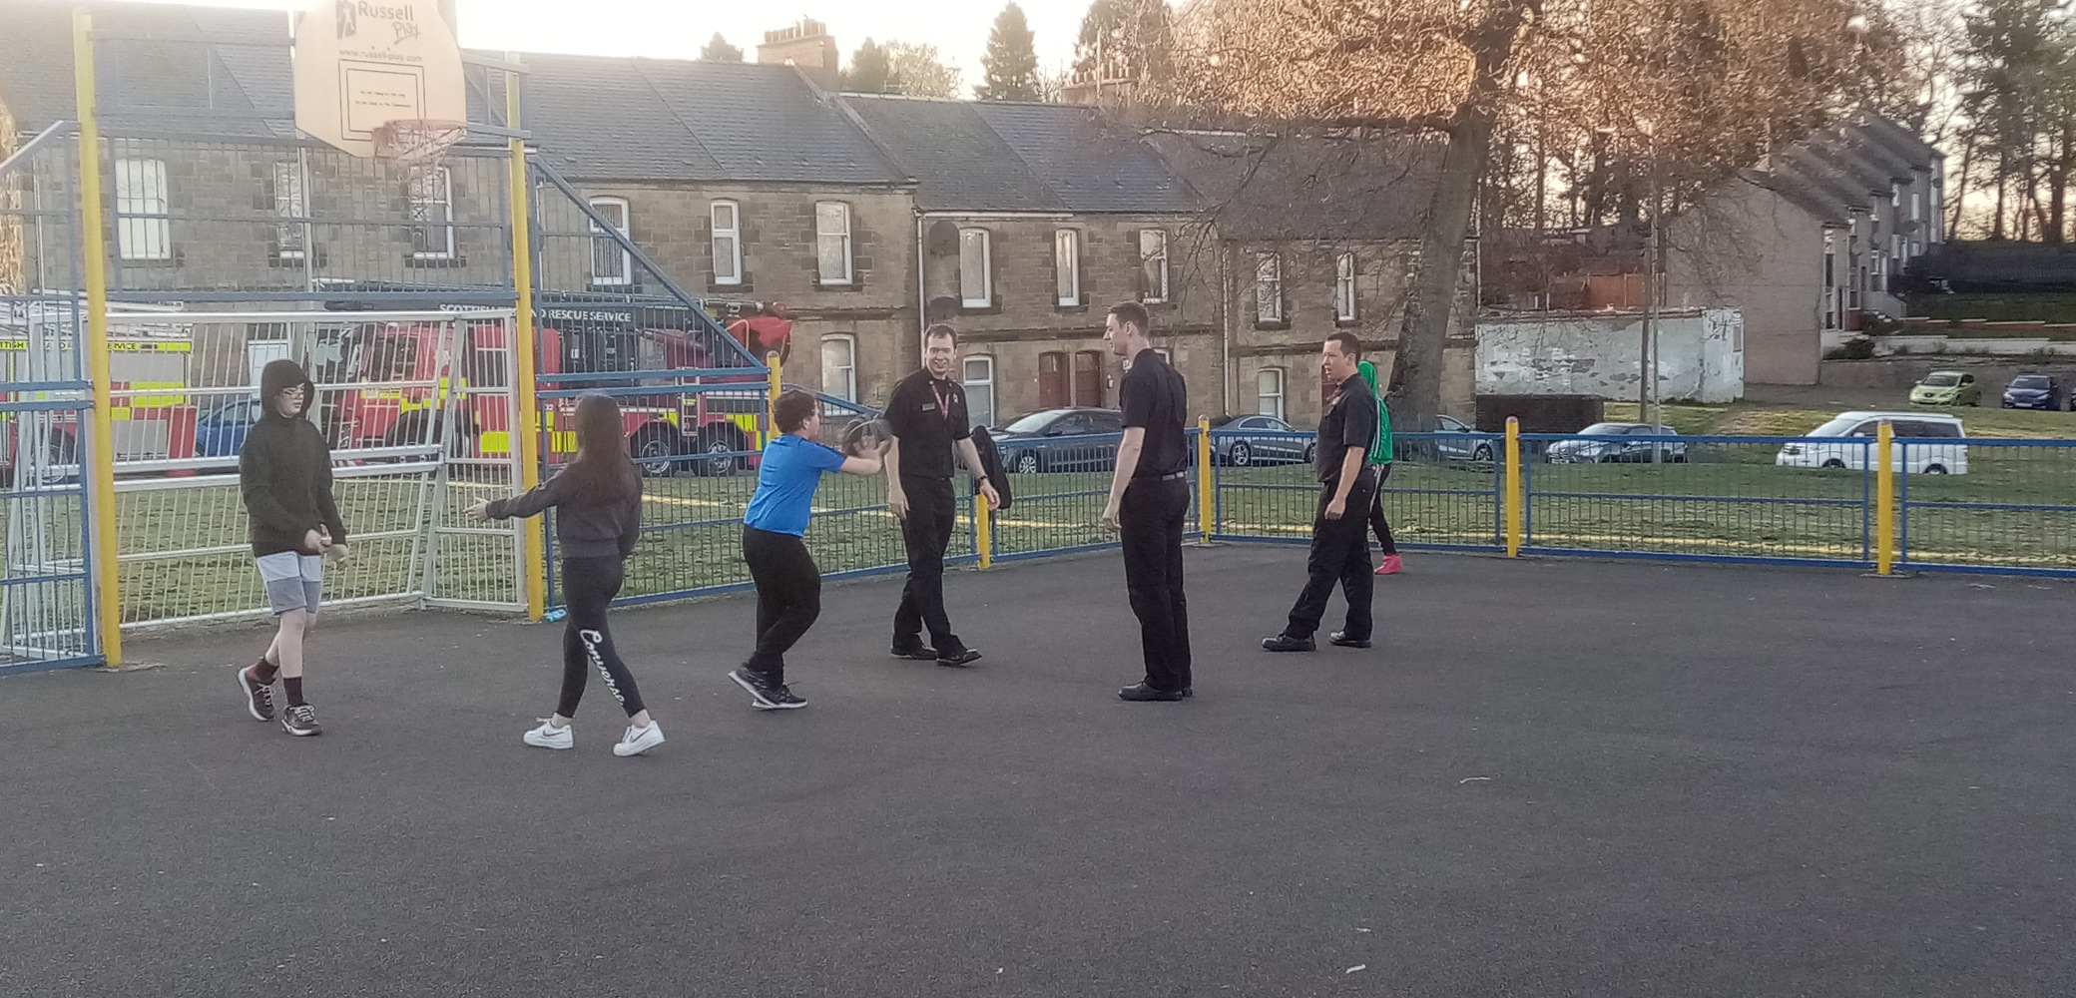

Key Quantitative data gathered over the 14-week programme: (A detailed breakdown of quantitative date is appended to this report)
- 324 young people took part over 14 weeks: 155 boys 48% & 169 girls 52%
- Average session attendance was 23 young people: 11 boys & 12 girls.
- 82 boys 12 years or younger ,57 boys 13-15 years took old part over the 14 sessions
- 92 girls 12 years or younger, 39 girls 13-15 years old took part over the 14 sessions
- 53% were 12 years or younger, 30% were between the ages of 13-15 years old & 16% were over 18 years old.
- Highest attendance at a session was 48 and the lowest attendance at a session was 9.
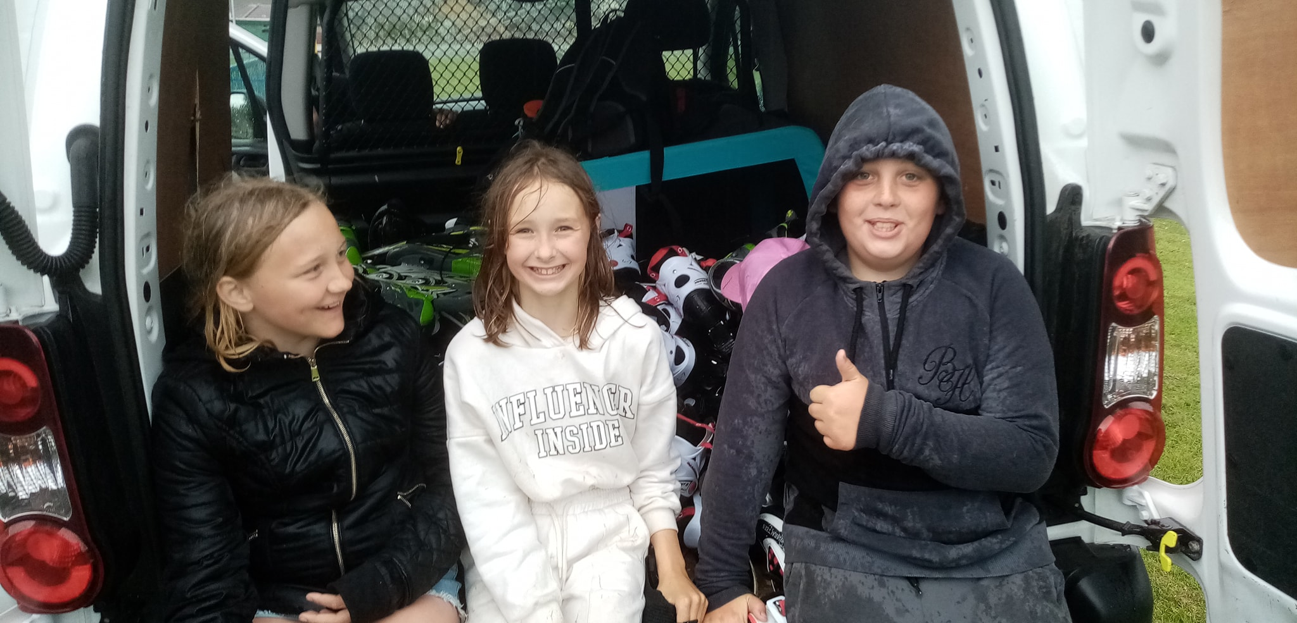

Average attendance by location:
- Carradale Avenue MUGA in Tamfourhill: 8 sessions, Average session attendance: 21 young people, 9 male & 12 females.
- Easter Carmuirs Park: 3 sessions, Average session attendance: 24 young people, 15 males & 9 females
- Nailer Road Park: 3 sessions, Average session attendance: 27 young people, 13 males & 14 females.

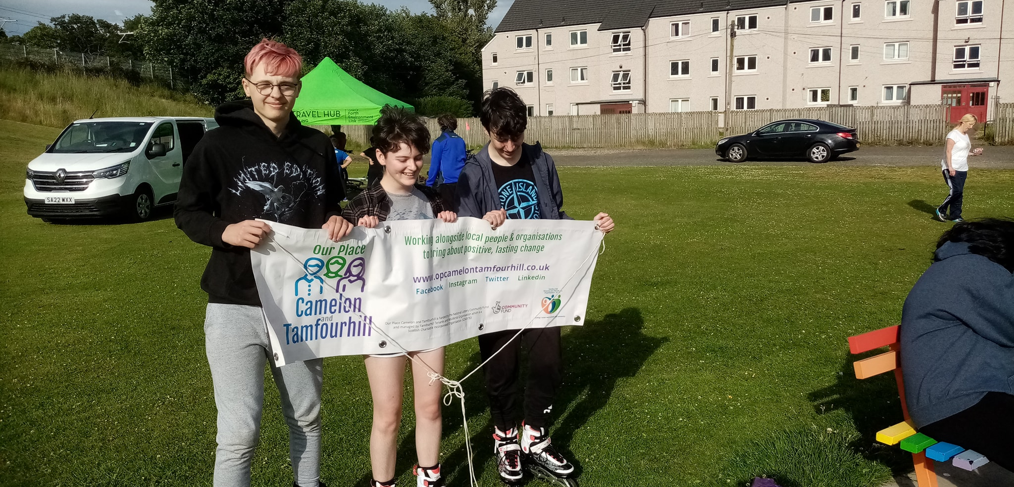

62 Young People and family members in attendance completed evaluation sheets, here are the responses:

- Please tell us how much you enjoyed coming to the twilight sports sessions on a Friday night. (Please tick the face that best describes your feelings)





- or 93% 3 or 5% 0
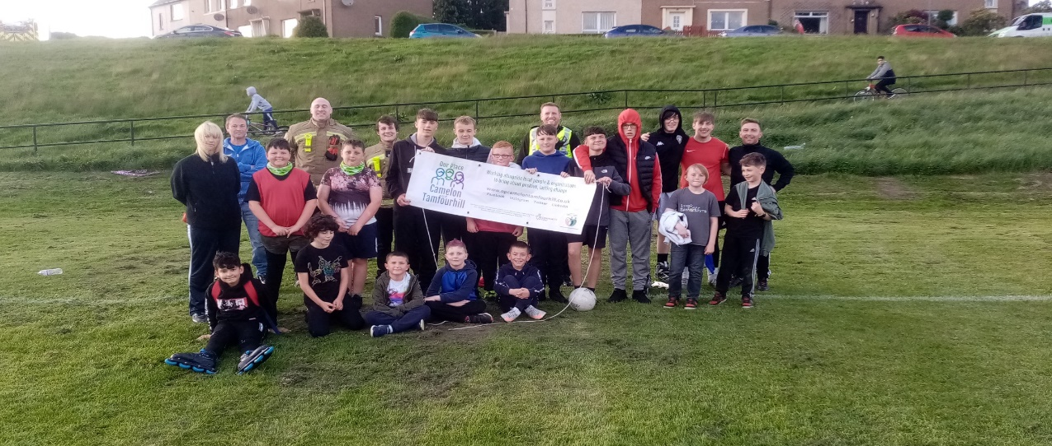

2 Please tell us one thing you really liked about coming along to the twilight sports sessions.
Here are the responses in a word-cloud:
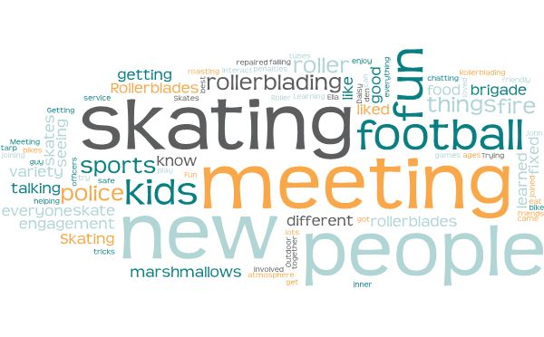
- Is there anything that could be changed or improved to make the sessions better for you?
Here are the responses in a word-cloud:

- How likely are you to go and take part in the twilight sports sessions at other locations or parks in Camelon & Tamfourhill (Score between 1 for not likely at all to 10 Yes, I will definitely go to other locations or parks)
Average score of all respondents was: 7.92
- Please tell us how you felt about the different services like the Police, Fire Service, Community Safety Engager and Health Services coming along to take part in the Twilight Sports Sessions. (Please tick the face which best describes your feelings)

- or 87% 7 or 11% 0

- How likely would you be to take part in the twilight sports sessions if they were to be run again in the future? (Score between 1 for I would never take part again to 10 Yes, I would definitely take part again)
Average score of all respondents was: 8.92

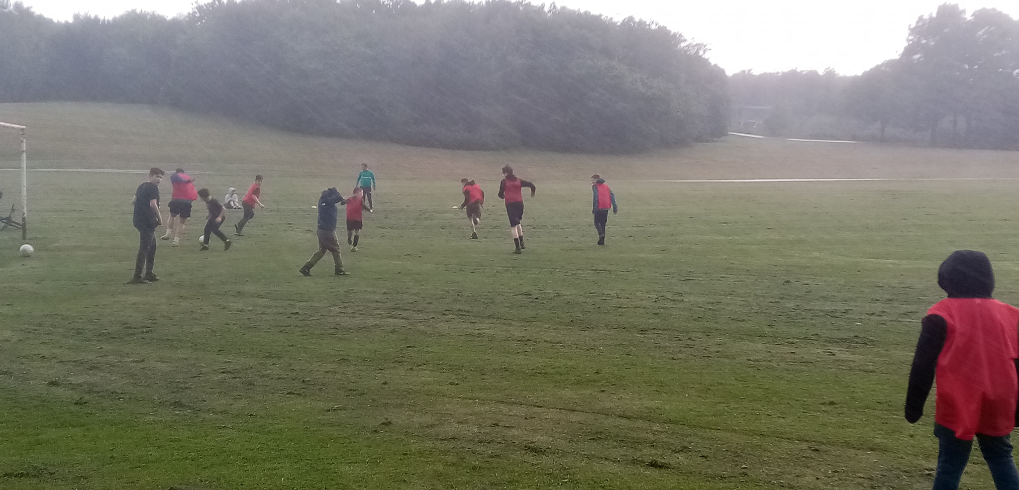

Community Safety Impacts:
- The sessions were well attended and over time a core group of young people got involved on a weekly basis and went to all of the locations throughout the community. The sessions engaged young people who were not involved in sport and other community-based activities.
- The Programme successfully targeted young people who are negatively impacted by health inequalities, it provided semi structured sports and play sessions that encouraged excellent physical activity and promoted mental wellbeing. In addition, every participant was provided with something to eat and drink, and this had a notable positive impact. The locations of the sessions were all in the close proximity to three data zones within the top 5% SIMD.
- Young people grew in confidence as their abilities and skills progressed over the weeks of the programme. The informal and unstructured approach evolved and worked well and was appropriate to the young people who attended where multiple sports and activities happened concurrently with positive coaching and 1-1 tuition going on throughout each weekly session.
- The sessions provided a safe space for young people to take part in sporting and outdoor activities and engage with their peers in a welcoming and supportive environment. A key benefit of the programme that was consistently highlighted in the evaluations was the opportunity to meet new people whilst taking part in enjoyable sports and activities.
- The young people valued and looked forward to the weekly involvement of the local community Police officers and the respective crews attending from Larbert and Falkirk fire stations. The willingness of these Services to muck in and take part facilitated positive relationship building with the young people and this was also acknowledged and appreciated by the wider community.
- The Forth Environment Link Dr Bike service attended 4 sessions and this was incredibly popular, repairs and services were carried out on numerous bikes providing young people and families with access to this important community safety provision and thus encouraging safe active travel throughout the community. Some bikes were noted to be in a bad state of disrepair and a serious risk to the safety of their riders, the twilight sports programme can build on this partnership providing a crucial bike maintenance service and encourage greater safe active travel throughout the area. FEL recorded 75 attendees with 24 bike repairs carried out at their Dr Bike Pop ups at the Twilight Sessions.
- The weekly programme was supported by parents, grandparents, and other family members and this added to the positive sense of community which developed around each of the twilight sports locations. Families were often involved together in the sports and the rollerblading in particular.
- The sessions attracted a wide range of ages with almost equal numbers of both boys and girls, the majority of regular participants were in the 10-13 years age range however older and harder to reach young people also got tentatively involved. Engaging this grouping is an area that needs further targeted interventions and the proposed linkage to a detached youth work programme can positively contribute to that process.
- The sessions facilitated positive relationship building with the Twilight sports staff, however the programme would be greatly enhanced by having youth work staff in attendance to engage with all the young people and to target the young people on the margins of the activities as described above. There is an evident need for youth work support, 1-1 engagement and developmental work to be progressed and the twilight sports can provide an excellent context for initiating additional community development and issue-based group work.
Comments from Community Safety Partners & Key Stakeholders:
- From a Community Policing point of view, it was brilliant to see so many kids attending on a weekly basis who all genuinely enjoyed being there. Having mixed activities and bike repairs etc was fantastic for the local community. With Police in attendance, it gave us the chance for some quality engagement with the local youngsters which helps build rapport and positive relationships with them whereas prior and undoubtedly so, the relationship would have been negative. PC Robert Hill: Falkirk Community Policing Team
- The twilight sports programme is helping to reduce health inequalities and providing outdoor activities for those most in need. The sessions have mixed age groups of young people taking part with sport within the community, thus allowing open access provision that can then provide a route to targeted support for young people. The sessions have provided the young people with the opportunity to meet other young people, take part in taster sport sessions and have access to food provision in a safe manner within their own community. Through the direct engagement with the Fire brigade and local community police officers’ young people have had the opportunity to build positive relationships and this has helped to break down barriers with these services: Lynne Boslem Treasurer Tamfourhill Community Hub.
- The twilight sports programme gave the Scottish Fire and Rescue Service regular opportunities to engage directly with the residents of Camelon and Tamfourhill and the sports events allowed operational crews to meet and speak to young people in a positive and constructive setting, which was really important following reduced schools contact due to Covid restrictions. This engagement is vital in order to highlight the negative impact and cost of fire related ASB upon our communities and to promote good citizenship amongst our young people. Gordon McCaig: Local Authority Liaison Officer-Falkirk & West Lothian Fire Service.
- The Twilight sports programme was great and is exactly the type of activity that is needed locally, it gave a new opportunity for young people from all over Camelon and Tamfourhill to get involved in sports in a fun way and that was really appreciated by the community. The involvement of the local police and fire service was an important part of the Friday night programme, it was very well received by the community and loved by the youngsters. The Tamfourhill Tenants and Residents Organisation would be very happy to support and encourage the continuation of the twilight sports project. Shona Craig Secretary Tamfourhill Tenants & Residents Organisation.
- For FEL, working in partnership with the Twilight Sports allowed us to engage with people we might not otherwise have been able to. I think the multiple event activity worked really well and gave a sense of occasion/something’s happening rather than a standalone pop-up hub. There was more purpose to what we were doing, and I would value more of this. The major impact for FEL was the realisation that Dr Bike cannot fix everyone’s bikes and the majority of bikes we serviced during the twilight sessions needing much more repairs than just a tweak. This was down to household poverty and the consequence this has on not only being able to repair bikes but also the inability to access the shops which offer this service. One of the outcomes for FEL is to work towards a skills academy which operates in the heart of the communities that need our help. The connections and partnership FEL made through the programme will help make this happen and without those partnerships’ delivery of these legacy events and ideas would be much harder to deliver and would have taken much longer to realise. Shirley Paterson Active Travel Development Manager: Forth Environment Link
- The sessions were popular and well attended with enough enthusiasm and interest from all attending for them to continue if possible. Football and skating were the two most popular sports with the football coaches and Falkirk wheeler would be keen to keep something running for the area both indoors and out. The police and fire services were always popular with the youngsters and their involvement with the other groups attending was always appreciated. The Falkirk Wheelers have been piloting sessions in primary and secondary schools which have all be a huge hit, and our intention is to make our kit available to schools on weekdays and to train the teachers and any other staff available to deliver the sessions. Gregor Watson The Falkirk Wheelers.

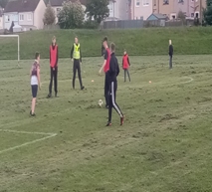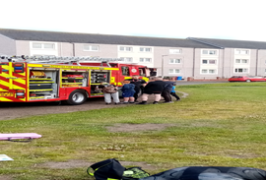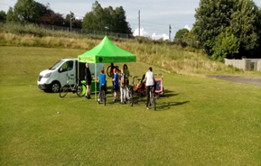

The next steps:
- In the short term Examine options for extending the programme over the winter 2022/23, this would necessitate utilising indoor locations and delivering in a more structured and focused manner. In this respect the community safety inputs could be more participatory, and workshop focussed, and opportunities should be explored to involve other partners including Transform Forth Valley and Health Services.
- Potential winter locations could include: Carmuirs & Easter Carmuirs Primary schools and Tamfourhill Community Hub.
- The proposed detached youth work programme should be closely linked to the twilight provision, this would include wrapping direct youth work support around the twilight sessions in order to engage directly with young people and develop additional opportunities with them that are appropriate to their interests, issues, and aspirations. This would enable further positive involvement for young people who are not involved with other youth activities or sports. The development of the youth Pod at Tamfourhill Community Hub could be incorporated into this approach.
- Additional funding should be sought from Camelon Community Sports Hub to support both this indoor winter programme and to ensure continuity of service and sustaining young people’s involvement this funding would also be required to support the programmes delivery back outdoors from April through to October 2023. The ongoing detached youth work programme would be closely linked to this process through the winter back into the summer.
- Food poverty can be partially addressed through the delivery of this Programme and the extension of the healthy diet and provision of food and drink approach should be extended as the programme is run out over the winter and then into spring/summer of 2023.
- Efforts should be made to involve young volunteer sports coaches with the delivery of the programme, providing excellent learning opportunities and hopefully build the capacity and capability of the local community to sustain the twilight sports project in the longer term. Volunteer and paid coaching opportunities for local people should be closely linked to the coaching development programmes supported by the Community Sports Hub and through the active school’s programme.
- A longer-term community safety consideration is to establish a full-time youth project for Camelon and Tamfourhill, and in this respect the twilight sports programme would be fully integrated into any future funding bids or strategic plans to establish new youth services and provisions for Camelon and Tamfourhill.
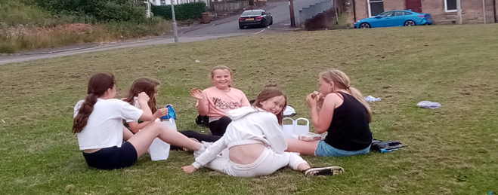
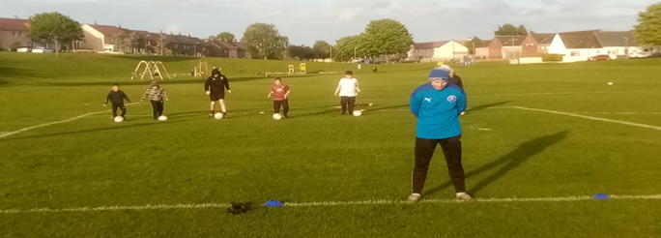

APPENDIX: I
Full programme and attendance data

Date: 6pm-9pm all sessions | Location | Programme
22nd April | Carradale Ave MUGA | Falkirk Wheelers & The Conservation volunteers
29th April | Carradale Ave MUGA | Falkirk Wheelers
6th May | Carradale Ave MUGA | Falkirk Wheelers & The Conservation volunteers
13th May | Carradale Ave MUGA | Falkirk Wheelers
20th May | Easter Carmuirs Park | Football, Falkirk Wheelers & Forth Environment Link Dr Bike
27th May | Easter Carmuirs Park | Football, Falkirk Wheelers & Forth Environment Link Dr Bike
10th June | Easter Carmuirs Park | Football & Falkirk Wheelers
17th June | Nailer Road Park | Football, Falkirk Wheelers & The Conservation volunteers
1st July | Nailer Road Park | Rugby & Falkirk Wheelers &Forth Environment Link Dr Bike
8th July | Nailer Road Park | Rugby & Falkirk Wheelers & Forth Environment Link Dr Bike
15th July | Carradale Ave MUGA | Football & Falkirk Wheelers
22nd July | Carradale Ave MUGA | Football & Falkirk Wheelers
29th July | Carradale Ave MUGA | Football & Falkirk Wheelers
5th August | Carradale Ave MUGA | Multi sports session, The Conservation volunteers & Community barbecue

Total Attendance Twilight sports April-August 2022

Age Range | Male 12 years & under | Male 13-15 years old | Male 16-17 years old | Male 18+ years old | Female 12 years & under | Female 13-15 years old | Female 16-17 years old | Female 18+ years old
Carradale Ave MUGA | 34 | 24 | 0 | 15 | 54 | 21 | 0 | 23
Easter Carmuirs Park | 26 | 18 | 0 | 1 | 19 | 3 | 0 | 5
Nailer Road Park | 22 | 15 | 0 | 1 | 19 | 15 | 1 | 9
Totals | 82 | 57 | 0 | 17 | 92 | 39 | 1 | 37
% Totals | 25 | 17 | 0 | 5 | 28 | 12 | 0.3 | 11

