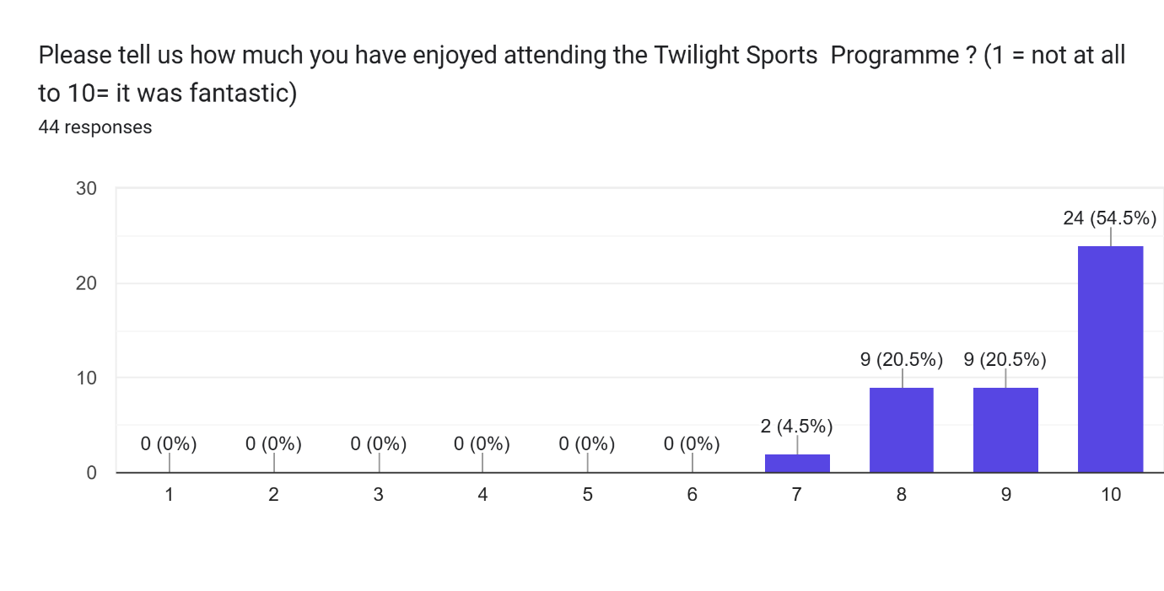
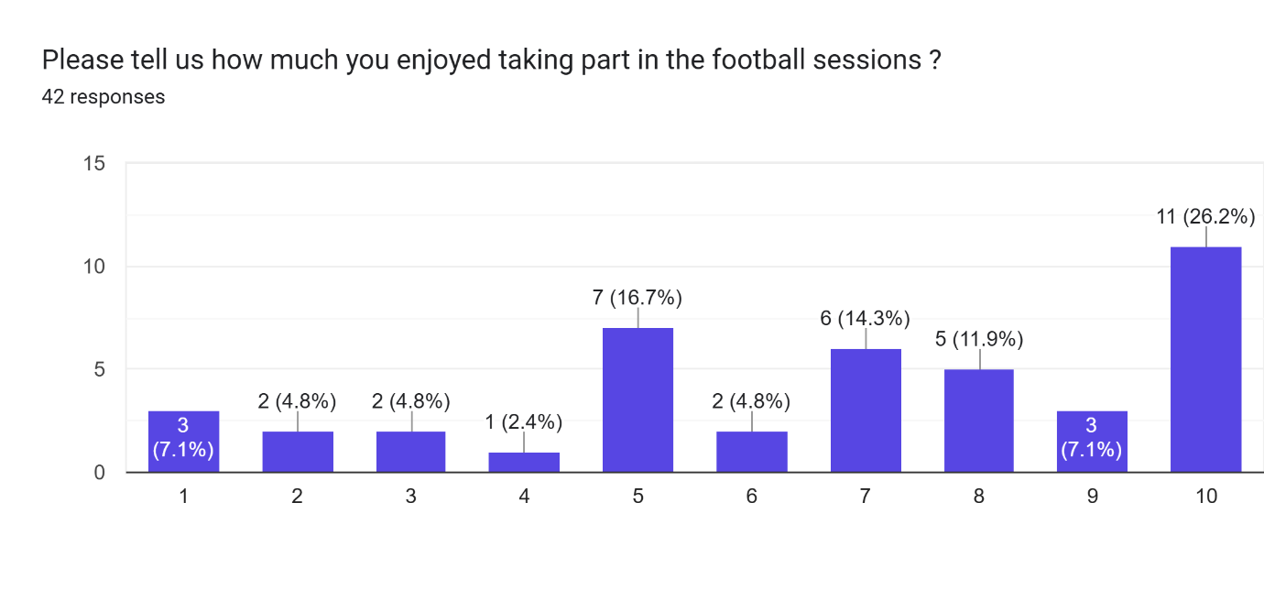
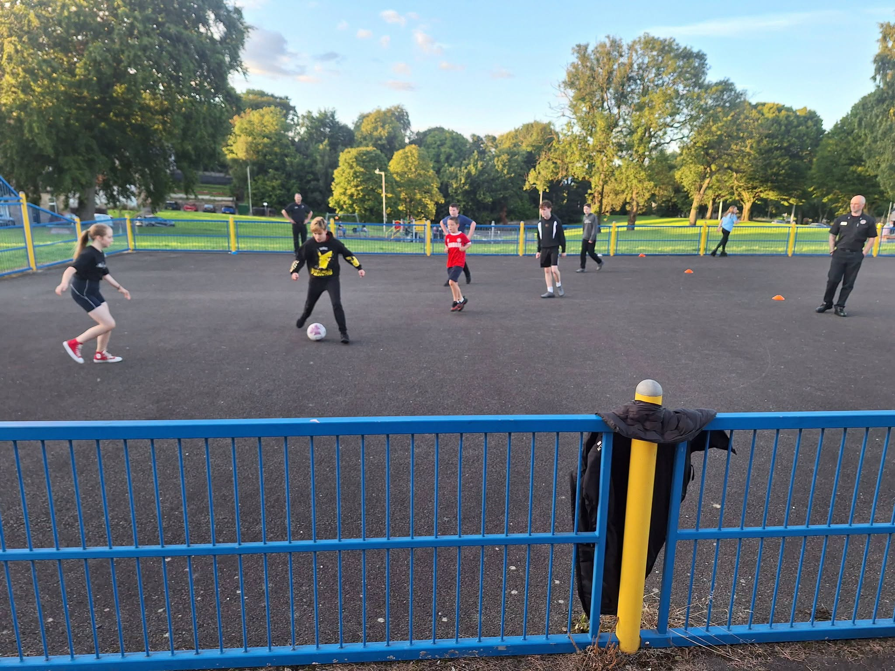
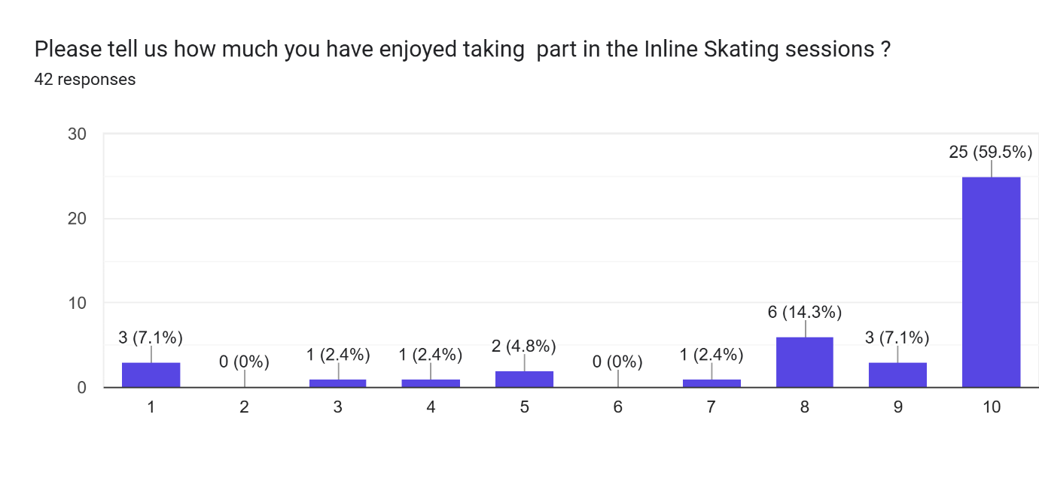
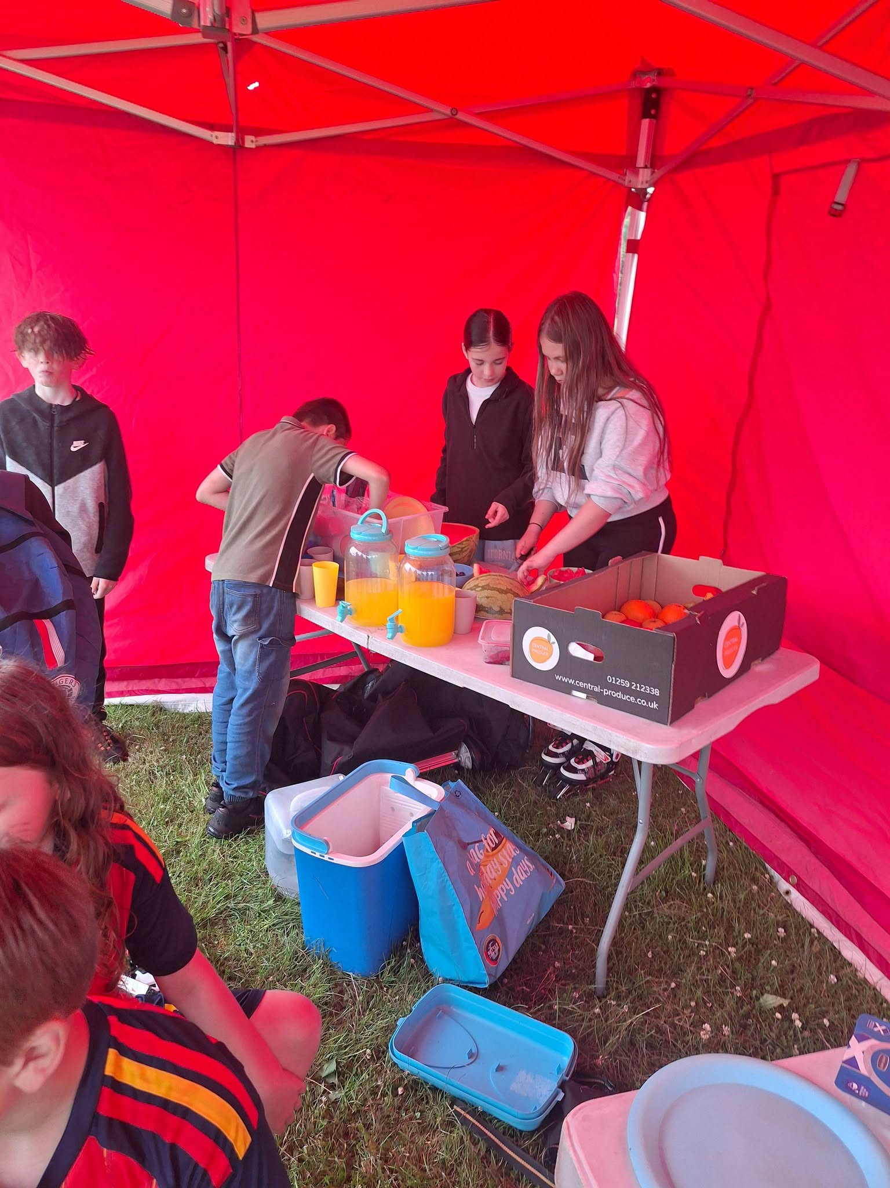
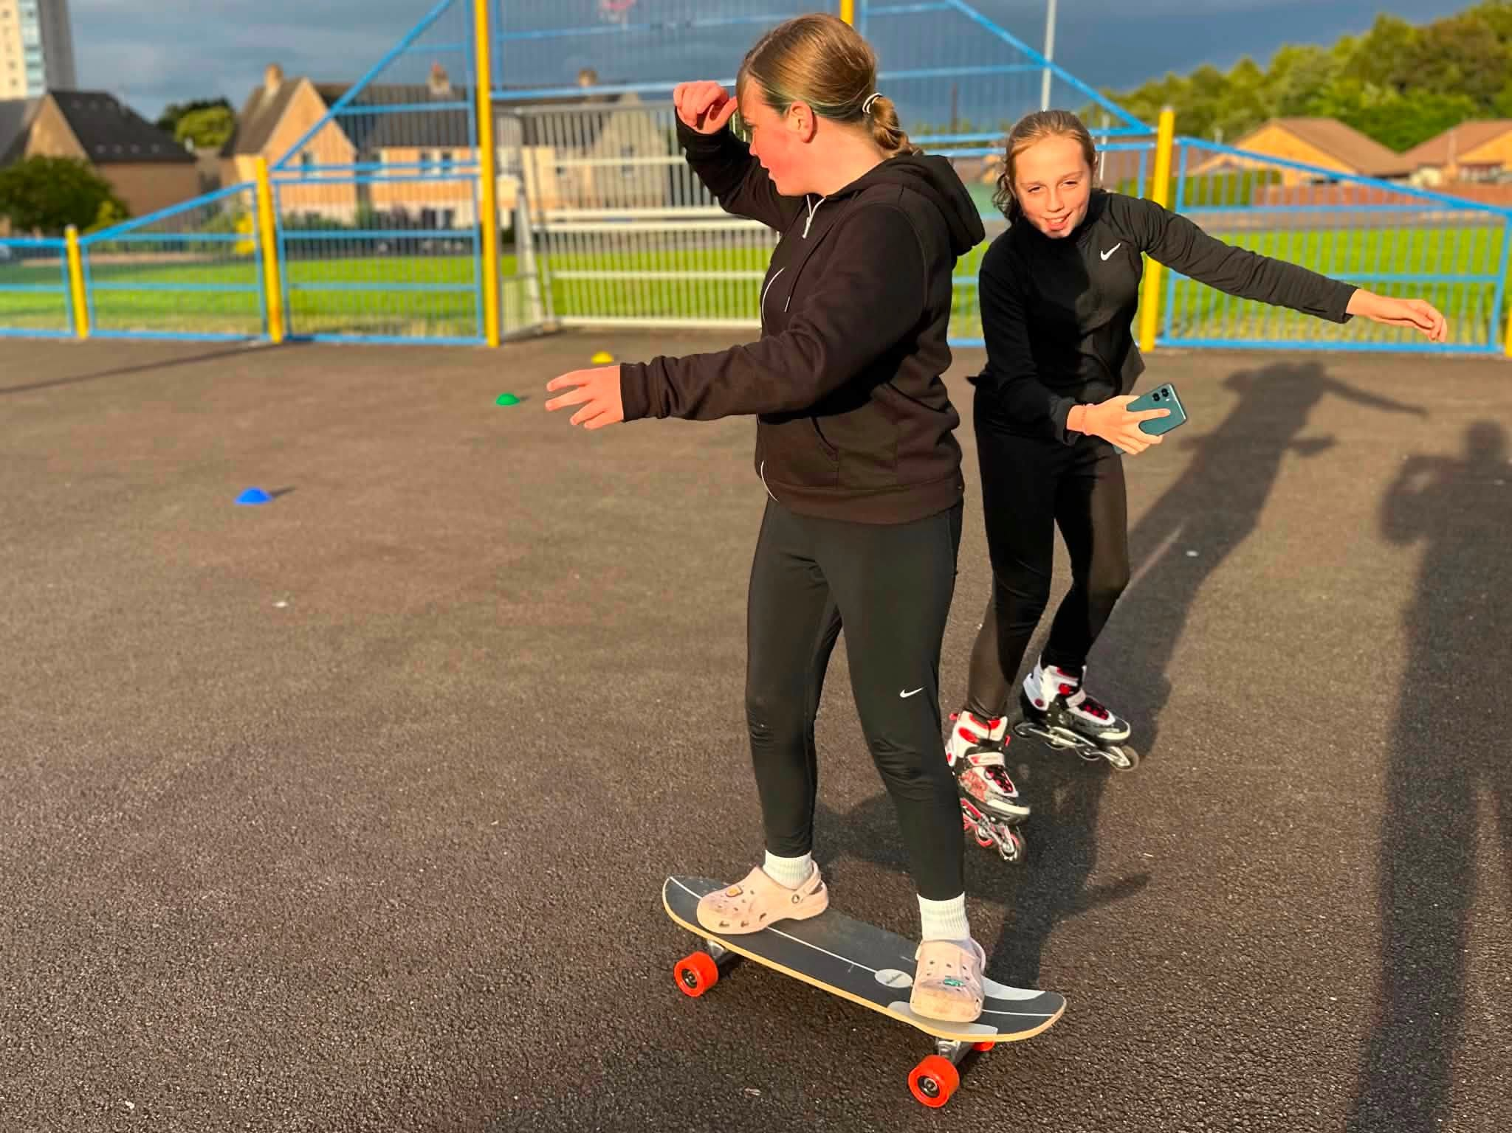

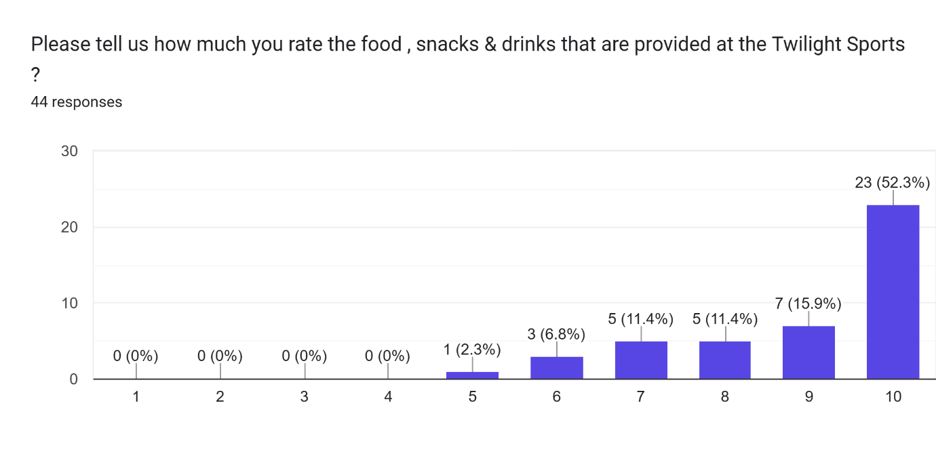
Our Young volunteer carried out vox pop interviews with young people throughout the Twilight Summer Programme, the repondents could however only reply using one word to desribe their experiences of attending the sessions, this can be viewed here; twilight sports evaluation voxpops Summer 2026
Thinking about how you rated the previous questions , please now tell us in a few words, why you come along on a Friday evening and what makes it an important activity for you?
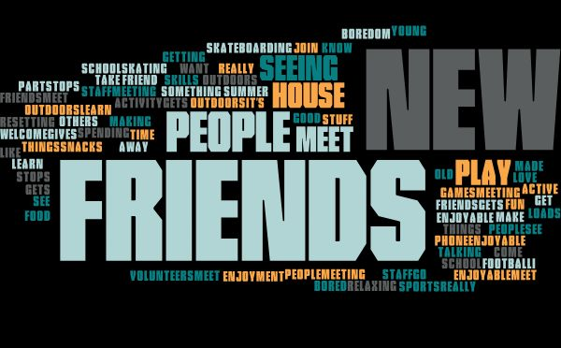

Are there ways that we could improve the Twilight Sports ? Please tell us what they would be?



Age & Gender | Male  10-12 | Male  13-16 | Female  10-12 | Female  13-16 | TOTAL | Ave per  session | Ave  Male | Ave  Female
Easter Carmuirs Park | 25 | 10 | 23 | 7 | 65 | 16 | 9 | 7
Nailer/Simpson Park | 29 | 9 | 26 | 22 | 86 | 21 | 9 | 12
MUGA | 24 | 25 | 23 | 25 | 97 | 24 | 12 | 12
Totals | 78 | 44 | 72 | 54 | 248 | 21 | 10 | 10
SCYAP delivered 12 Friday night Twilight Sessions throughout the Summer 2026 in three different public parks in Camelon & Tamfourhill: Here is the breakdown of attendance by ages, gender and locations:

Thanks to our community Safety Partners who delivered throughout the programme : FEL Dr Bike Service along with the regular visits from the Scottish Fire & Rescue Service crews from Falkirk and Larbert Fire stations.
Inline skating & skateboarding were delivered by the Falkirk Wheelers and our football coaching delivered by Caiden Wilson. Thanks to all of these coaches for their expertise and commitment to the Programme.
Well done to our young volunteers Leo, Ella and Victoria , and the rest of staff team ; Julie, Alex & Rachel. We also appreciate the kind support from the Tamfourhill Community Hub volunteers and their Project Worker Louise who helped out with our food provision and provided other support on a number of occasions.
Our funders; the National Lottery Young Start programme, KFC Youth Foundation and BBC Children in Need.
For further details please contact:
John R Hosie
Youth & Community Development Worker
Safer Communities Youth Action Project
john@ttrohub.co.uk
07391524528
Visit our website: https://saferstreetsyouthaction.co.uk//
Facebook: https://www.facebook.com/Saferstreetsyouthactionproject/

